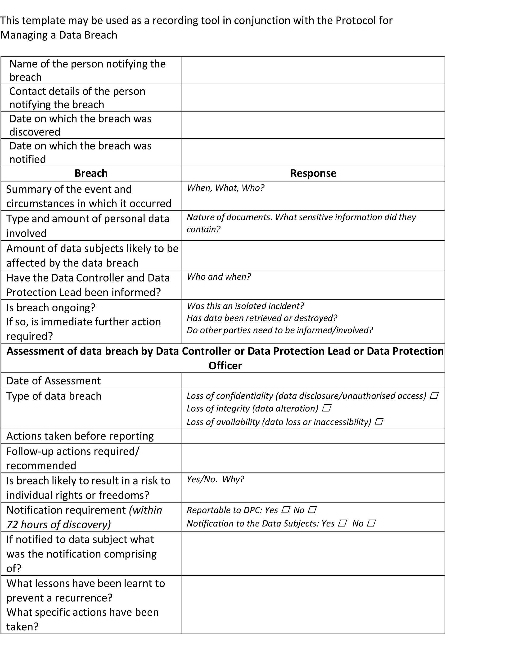
Appendix L: Data Breach Reporting Template

54

